Valence Environmental, Social and Governance Report 2021

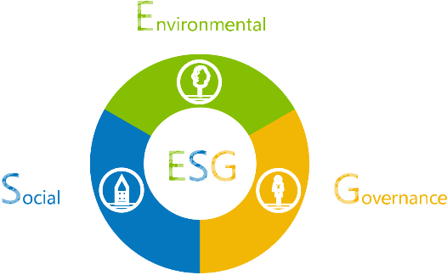
Valence Surface Technologies and its business entities strongly believe in the importance of environmental, social, and corporate governance (“ESG”) to our business. We aspire to be responsible corporate citizens and believe that transparency and accountability are important foundations for creating value and building trust with our stakeholders to fulfill our long‐term mission, vision, and strategy.
In 2021, we formally established our ESG policy, identifying the ESG considerations relevant to our business and integrating them into our business practices to ensure that ESG risk factors and opportunities are considered on a continuous basis. Our ESG program and policy is maintained by our CHRO and is reported quarterly to the Board of Directors. The purpose of this letter is to update our key stakeholders on the progress we have made towards achieving the goals set forth in our ESG policy in 2021.

Environmental

Our environmental program is rooted in a commitment to protect and maintain the environment and minimize the impact our actions may have on it. We achieve this through eco‐efficient management strategies and continuous improvement while working with local agencies to meet regulatory standards.
A core tenant of our business is quality and compliance. In accordance with this, we conduct all of our operations in compliance with applicable environmental laws, regulations, and internal policies and procedures.
- We undergo regular air, sanitary, sewer, fire, and Ecology/DEQ audits. Third Party audits resulted in no significant findings or violations. Valence has received accolades for environmental stewardship, including a Gold rating for compliance from a local regulatory agency and a nomination for pollution prevention accomplishments.
In addition to complying with all laws and regulations, we have taken actions that go above and beyond legal and regulatory requirements to reduce our environmental impact while still delivering on our commitment to our customers and key stakeholders.
- In both 2020 and 2021, we have monitored all corporate travel and engaged in a carbon offset program with Sustainable Travel International to neutralize the impact our corporate air travel has on the environment.

- We have completed a review of 2021 air travel and finalized our 2021 offset efforts and are proud to include our 2021 Offset Certificate!
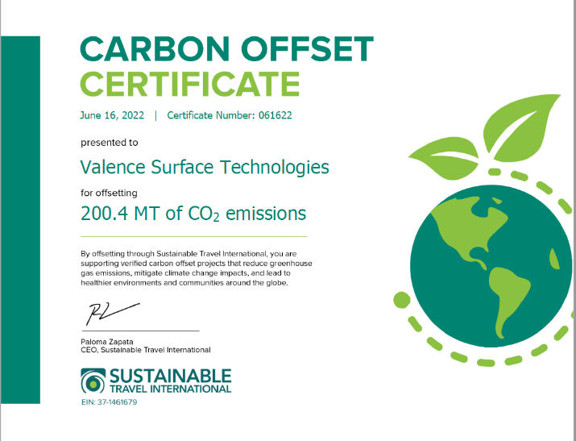

Furthermore, in 2020 we began a facility consolidation process, which involved reducing our rooftops in the Los Angeles, California region from four to two. The closure of one of these sites—the Gardena facility—was enacted primarily for environmental considerations and meaningfully reduces our overall environmental impact.
This consolidation process was formally completed in 2021 and resulted in the elimination of:
- 500,000 pounds of hazardous waste;
- 700,000 kWh of electricity;
- 250 Therms of natural gas;
- 14 million gallons of water annually.
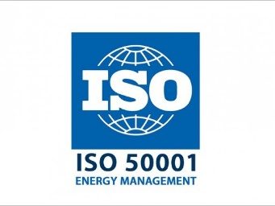
Other company wide efforts to impact the VST environmental footprint include:
- Monitoring electricity, water and natural gas consumption and air emissions to address waste and inefficiencies;
- Enrollment in the DOE sponsored ISO 500001 Ready Program to prepare the organization for formal accreditation;
- Elimination, reduction, or substitution, where possible, of materials that have detrimental effects on human health and the local environment;
- Preferential consideration for recycling or destruction of hazardous wastes or processing byproducts;
- Raising awareness of and promoting use of reusable materials including, where possible, enabling the recycling of plastics, metals, and glass;
- Working together with our stakeholders on activities that promote environmental protection and stewardship;
- Source reclamation of spent materials and management of in-house processes to recycle wastewater for reuse;
- Improved inventory controls to ensure maximum utilization of time and temperature sensitive materials to reduce disposal of hazardous and excess material;
- Improved utilization power during times of peak demand.

Social

Our social program is rooted in a commitment to developing and deploying an engaged, diverse workforce, fostering a culture of transparency and organizational compliance, and giving back to our communities. We achieve this through an understanding that our employees are our most valuable assets and are critical to the success of our business. Valence also works to foster a culture of integrity and trust across all functions and locations withing our organization.

Health & Safety
Our commitment to our employees begins first and foremost with a commitment to their health and safety.
- In accordance with this commitment, we conduct Monthly Safety Committee meetings at each site, which involves education, training, and remediation of documented safety hazards, and audits related to issues such as chemical safety, equipment, training, and occupational hazard prevention.
- Worker injury ratings were maintained well below industry standard.
Valence received no formal findings during OSHA and State worker safety agencies in 2021.
During the COVID-19 pandemic, Valence was designated an “essential business” and, as such, our employees worked on location throughout the pandemic. As a result, beginning in 2020 and continuing through 2021, Valence established specific programs to ensure our employees remained safe and healthy:
- Valence invested in health and safety protocols and PPE for all employees and visitors, including the use of technology and automation to perform daily health screenings.
- We also offered additional paid sick leave (e.g., sick, stress, and care leave) to our employees. ATL provided a fund for employees and their families who were impacted financially by the pandemic.
- Employees were offered incentives and pay for time away from work related to COVID-19 vaccines.
- Valence arranged for mobile vaccination clinics to visit the workplace for employee convenience.
- The vaccine program achieved rates as high as 92% at individual sites with the majority of all employees being fully vaccinated.
- In 2021, we bolstered our policies by developing pandemic response plans that limited potential exposure while assuring that our customers’ needs were met.

Diversity, Equity and Inclusion

Valence is committed to maintaining an environment that encourages and fosters positive relations and respect for all individuals. We actively recruit people from diverse backgrounds to build a supportive and inclusive workplace, and we take steps to ensure employees have a sense of belonging, value, and opportunity. We are committed to enforcing the Code of Ethics at all levels in order to create an environment free from discrimination, harassment, retaliation, and/or sexual misconduct.
Discrimination or harassment based on race, religious creed, color, national origin, ancestry, physical disability, mental disability, medical condition, genetic information, marital status, sex, gender, gender identity, gender expression, age, sexual orientation, or military and veteran status, or on any other legally prohibited basis is unlawful, violates our company policy, and is not tolerated. Any form of retaliation against anyone who has complained of, or formally reported, discrimination, harassment, or sexual misconduct, or has participated in an investigation of such a complaint, regardless of whether the complaint relates to the complaining person or someone else, will not be tolerated, and violates both the company’s policy and applicable law.
To further promote this commitment to diversity and inclusion, Valence maintains or has enacted the following initiatives.
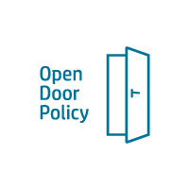
- We maintain an “Open Door” Policy that encourages employees to present ideas, ask questions, and raise concerns, especially those of a legal or ethical nature, and those relating to quality of work, directly to any level of leadership without fear of retaliation. We also re-launched the Valence Integrity Hotline in 2022 to further promote the “Valence Speak Up” culture we want to foster and support. This communication is essential to ensure our employees are fully aware of the Valence Integrity Hotline where concerns can be reported and to understand all reporters have the option to remain anonymous.
- In 2021, management began formally reporting diversity statistics to our Board of Directors, including across gender and ethnicity, as well as across its management.
- We are also launching our Diversity, Equity and Inclusion Policy.

Total Company – Diversity Metrics

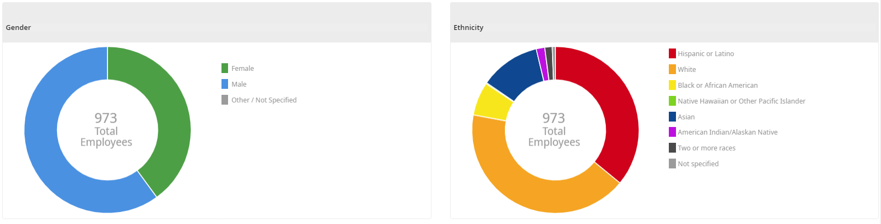

Community Engagement & Charitable Giving

While we work with various charities on a case‐by‐case basis in the local communities in which we do business, Valence is in the process of formally establishing a Community Reinvestment Plan, which will reward employees if they support local community charities, participate in local school activities, participate in fundraisers, etc. This commitment will not only support each specific community in which we operate but is also intended to foster a company-wide culture of giving that will boost employee morale and satisfaction. We expect this policy to be formalized and deployed in 2022.

Governance

Cybersecurity

We invest significant resources and constantly focus on Cybersecurity risks.
- We report on cyber and data security threats and mitigation quarterly to our Board of Directors
- Beginning with the 2021 audit, the Valence Audit Committee—a committee of the Board of Directors—formally reviewed cyber risk as part of the annual audit process
- We conduct the following periodic assessments and monitoring to mitigate the risk and impact from Cyber Incidents:
  - 24/7 monitoring of all internal and external network traffic
  - Monthly reviews with our Virtual Security Operations Center (vSOC) partner
  - Quarterly Vulnerability and Threat scanning on all networks
  - Annual network penetration testing from 3rd parties
  - Annual Cyber Risk Assessment review and Incident Response Plan review
  - Annual employee Cyber awareness training
Valence handles Controlled Unclassified Information (CUI), which is government-created or owned information that requires safeguarding or dissemination controls consistent with applicable laws, regulations, and government-wide policies.
- In 2021, the Department of Defense approved an Interim Rule to usher in a new enforcement framework. In response, management is undergoing a formal review of our processes and systems to ensure we are fully in compliance with the updated rule. We report on cyber and data security threats and mitigation quarterly to our Board of Directors.

Compliance and Management Operating System
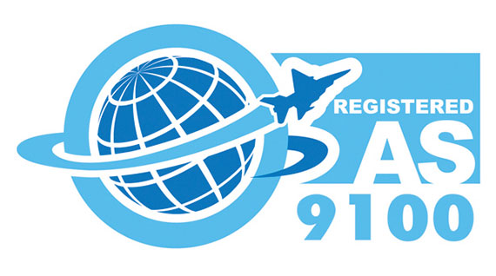
Valence ensures compliance with all relevant regulations through third party independent audits and our internal Management Operating System, which is intertwined with the aerospace industry specific AS9100 framework by which we operate, align activities, review risk, and make decisions. To maintain compliance within this system, we conduct monthly executive leadership team meetings, Monthly Operating Reviews, and Internal/External Quality audits. Valence also operates in compliance with all CUI, ITAR, EAR, and FAA regulations.
Each Valence site also conducts monthly internal audits with a focus on improving processes and mitigating business risk. There is an established quality meeting with the purpose of sharing all the results of all external and internal audits across all business sites for review, input and containment.
All AS/ISO audits are annual. Nadcap certification allows merit status after 4 successful annual external audits, which can allow for extension from annual to 18-24 months. However, each process is subjected to auditing internally on an annual basis.
- 10 out of 11 Nadcap audits are at Merit.
All Majors and Minor findings from audit have been shared and resolved through problem solving using cross-site best practices and shared knowledge.
Governance & Risk Management

Valence’s Board of Directors formally convened nearly a dozen times, including both quarterly Board meetings and ad hoc meetings to address specific topics, in 2021 to provide appropriate corporate governance oversight and review, among other things, the strategic direction, quality of leadership and management, internal controls, and operating performance. In addition to full Board of Directors meetings, Valence maintains two Board committees focused on critical governance and risk management areas—audit and compensation.
- In 2021, Valence conducted a third-party financial audit for the 2020 financials with our auditors, Grant Thornton. Throughout 2021, the Audit Committee oversaw the audit process and met with both management and the auditors. Following formal recommendation from the Audit Committee, the Board of Directors reviewed and approved this independent audit in March 2021.
- The 2022 audit process was completed in the first half the year. As previously covered, the process included a review of cyber risk by the committee.
- In 2021, the Compensation Committee established a review process for 2021 employee compensation programs, including salaries, bonuses, and equity-based compensation.

Conclusion
Valence is pleased to share the progress we have made towards our ESG commitments to date, and we look forward to continuing to provide updates on the Company’s continued developments. ESG remains a critical part of the company culture and is viewed as a part of the value creation defined by the company brand.

